#### LabVIEW Actor Framwork (3)\_\_\_\_\_\_\_\_ 边学边做server&client之打包应用程序

特意补充这一节的内容是因为，我在将Actor Framwork的demo打包发行时，遇到了几个问题：

### 一、EXE打包以后并没有弹出Server客户端，一闪而过？

### 想要在生成应用程序时打开Actor core.vi的前面板必须采用调用节点，而不能用Launch (Root) Actor 的open/close接线端。具体代码我采用条件禁用结构，当为打包程序时，就这里给Flase，源码时给True。至于为啥Launch (Root) Actor 的open/close接线端来设置打开前面板，具体原因参考LabVIEW帮助：

|  |  |
| --- | --- |
| IMG_256 | **Actor** specifies the initial state of the actor. |
| IMG_257 | **error in** describes error conditions that occur before this node runs. This input provides [standard error in](lvconcepts.chm::/using_standard_error_in.html) functionality. |
| IMG_258 | **Open Actor Core front panel?** specifies whether, on launching the actor, the front panel of the Actor Core method opens. The default is FALSE. The TRUE setting causes this VI to return an error in the run-time engine.  Set **Open Actor Core front panel?** to TRUE during code development so you can access the **Abort** button for the VI, which helps if you forget to stop an actor. To open the Actor Core front panel of an actor for purposes other than debugging, use the [Front Panel:Open](lvprop.chm::/VI_Open_Front_Panel.html) method. You can also enable **Show front panel when called** on the [Customize Window Appearance](lvdialog.chm::/Cust_Window_Appearance_DB.html) dialog box to configure this VI to open the Actor Core front panel when you call the actor. |
| IMG_259 | **Actor's Enqueuer** returns a reference to an enqueuer. Use this reference to send messages to the newly launched actor. |
| IMG_260 | **error out** contains error information. This output provides [standard error out](lvconcepts.chm::/using_standard_error_out.html) functionality. |

## Actor:Launch Root Actor Details

Refer to the Actor Framework template for more information about the Actor Framework. To use the Actor Framework template, click **Create Project** from the LabVIEW start screen and select **Actor Framework**.

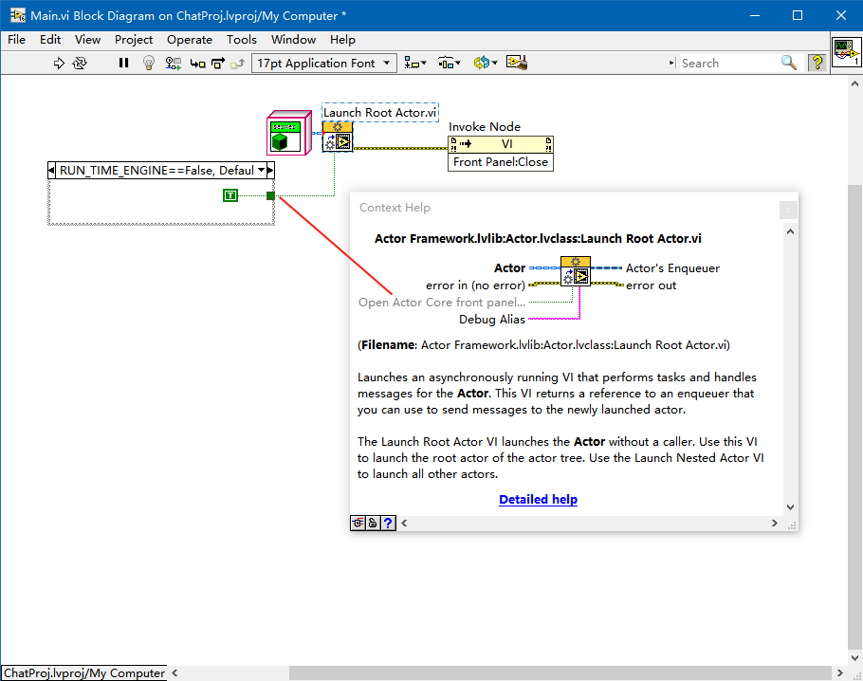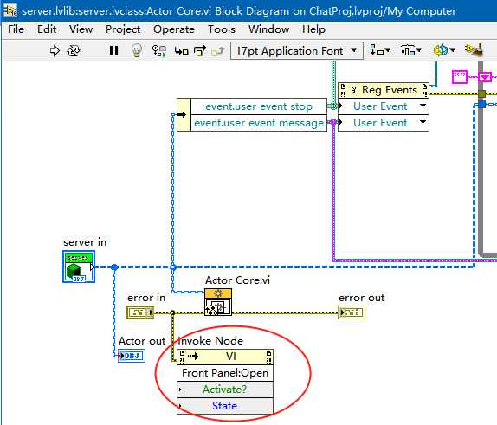

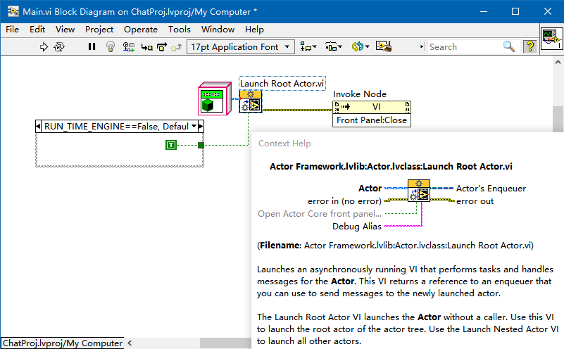

### 二、停止了server或者client界面，但是窗口依然存在，没有退出。

  最后这个问题同理，在Actor core结束时需要采用节点来关闭前面板窗口。具体实现如下，每个Actor core都一样的处理方法：

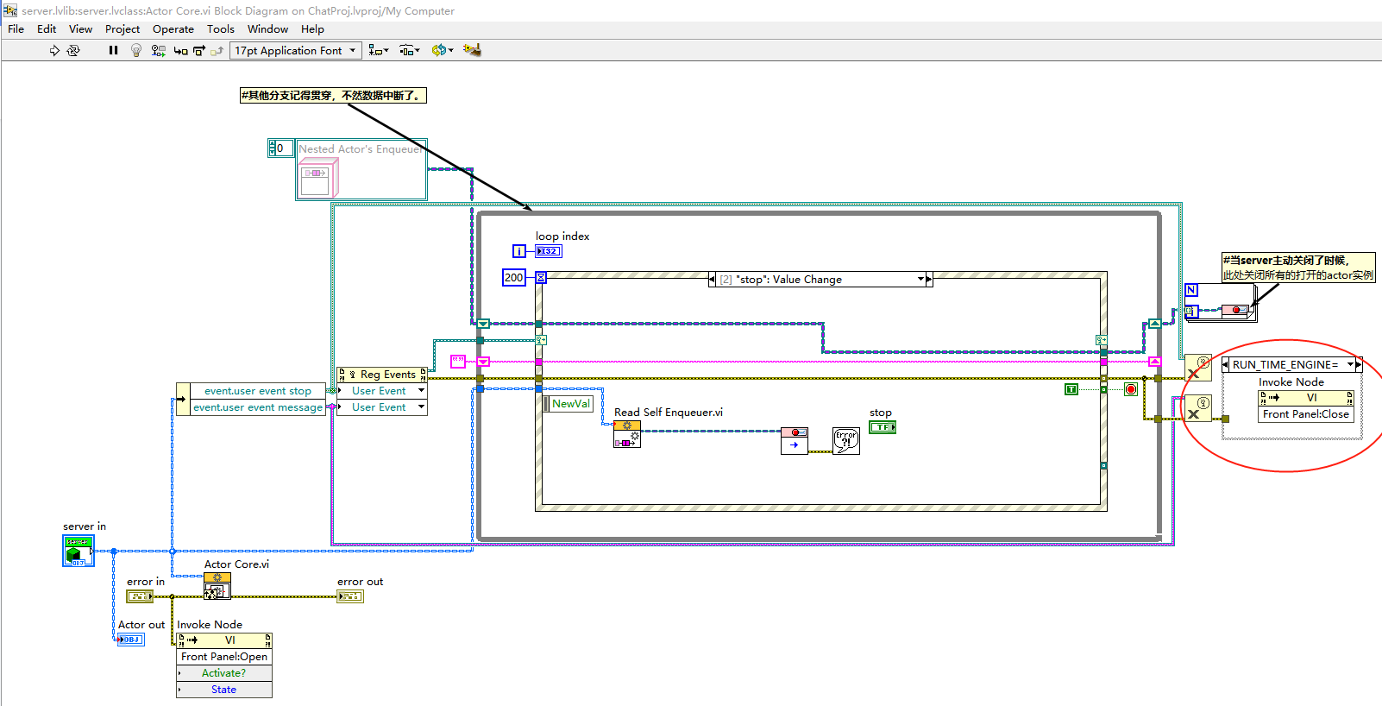

### 打包的工程设置技巧

记录几张图，将发布的exe分包为几个文件，这样以后可以实现单独升级单个文件以满足软件的升级：

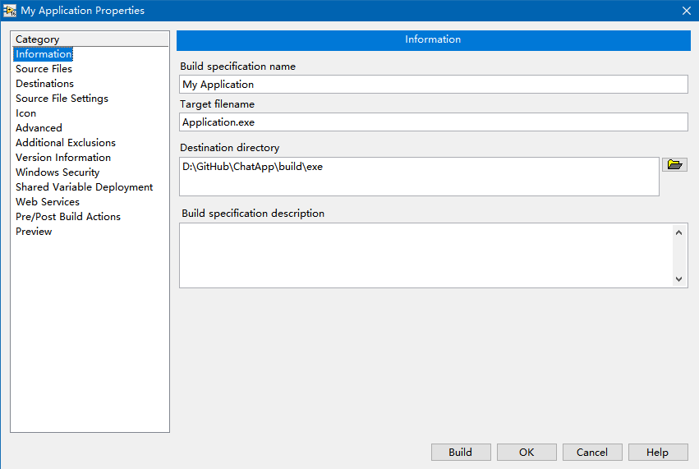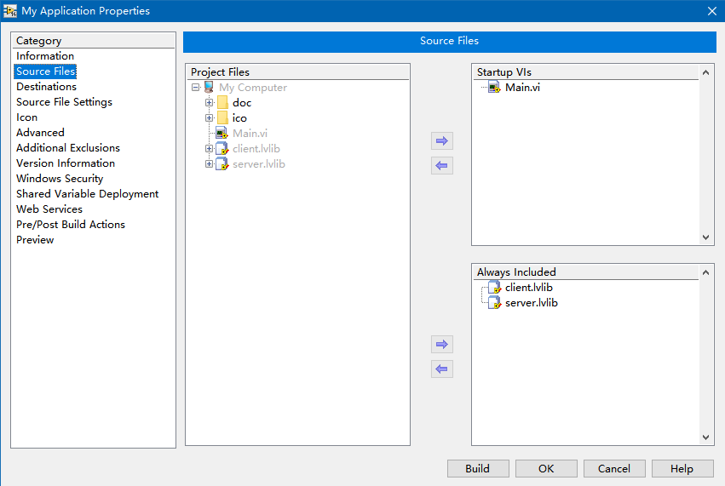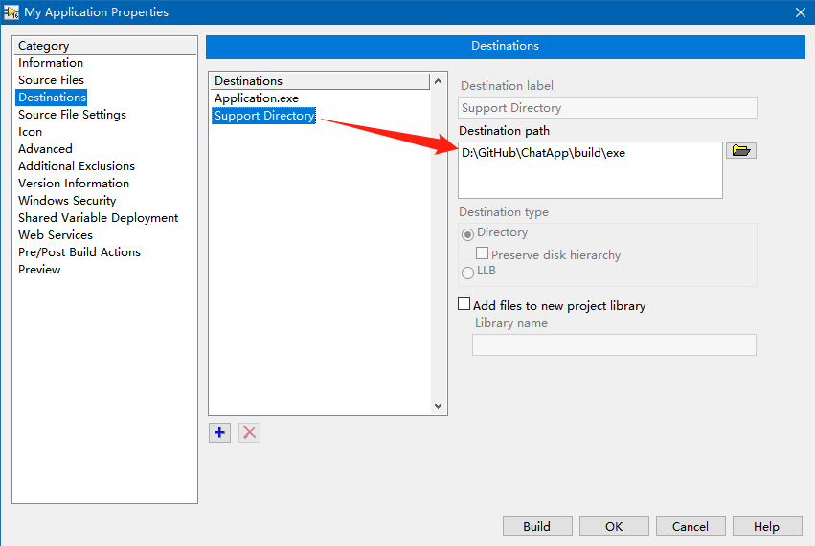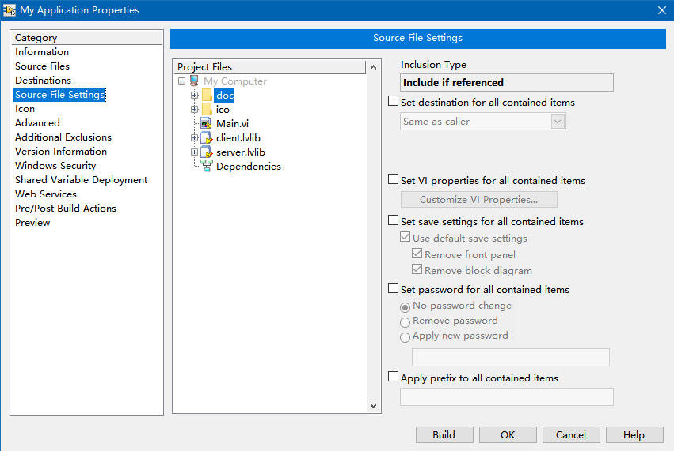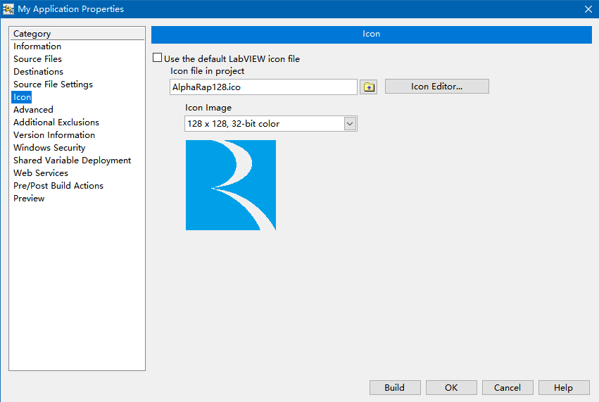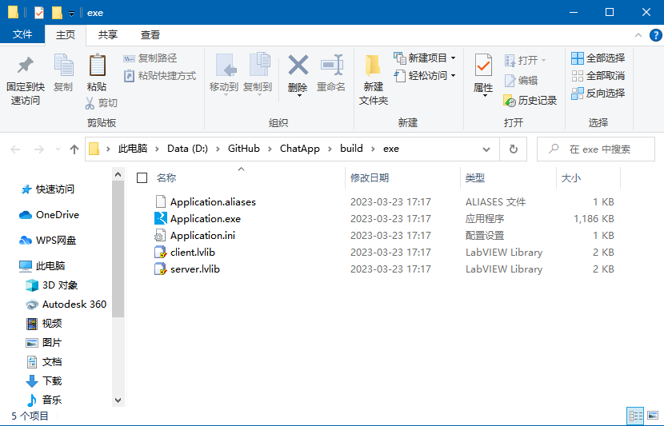

  ~~~~~~~~~~~~~~~~~~~~~~~~~~~~~~~~~~~~~~~~~~~~~~~~~~~~~~

Actor Framwork第一个边学边做的demo完结。

师傅引进门，修行在个人。

这只是个开始。。。。。。